MGMS – Grant Receipt

Functional Specification Document

Ver. 1.4

Version History
Version # | Date | Description
1.0 | 20-Oct-2010 | First draft
1.1 | 16-Nov-2010 | Added validation check error messages
1.2 | 02-Dec-2010 | Added mandatory check error messages

Table of Contents

Version History 2
1 Introduction 4
1.1 Purpose 4
1.2 Scope 4
1.3 Assumptions 4
1.4 Constraints 4
2 Grant Receipt 4
3 Business Rules 8
4 Status Messages 8

Introduction

Purpose

This document provides the requirements and functional specifications for the Multisite Grant Management System project.
This is not a project plan or a design document. It is a guide for system architecture and development, not for phasing, timelines or deliverables.
Finally, this is a ‘living document’ and the specification will change, continuously, as the project proceeds. More details will be added and the existing information edited as the requirements, scenarios and use cases evolve in the course of the project.

Scope

A receipt may be recorded by;
  - An account head which received an amount against the allocation made to it by its institution.
  - An account head of a grantee institution which received an amount (fund transfer) against the sub-allocation made to it by the grantor institution for a project.
Currently, the scenario of receiving a bulk amount for multiple allocations of a project or even multiple projects from a grantor institution is out of scope.

Assumptions

Both the Grantor and Grantee use the MGMS application.

Constraints

Grant Receipt

This is a record of acknowledgement of amount received.
    - The details associated with a grant receipt are: amount, date of receipt, funds received order no:, grant allocation against which fund was transferred, fund transferred against which grant was received, receiving account head name, mode of payment and related details (Cash/DD/cheque details, bank details etc)
    - Each grant receipt may be tracked by fund received Order no.
    - The information maybe updated later

Screen & Control Description

Figure 1: Receive Grant
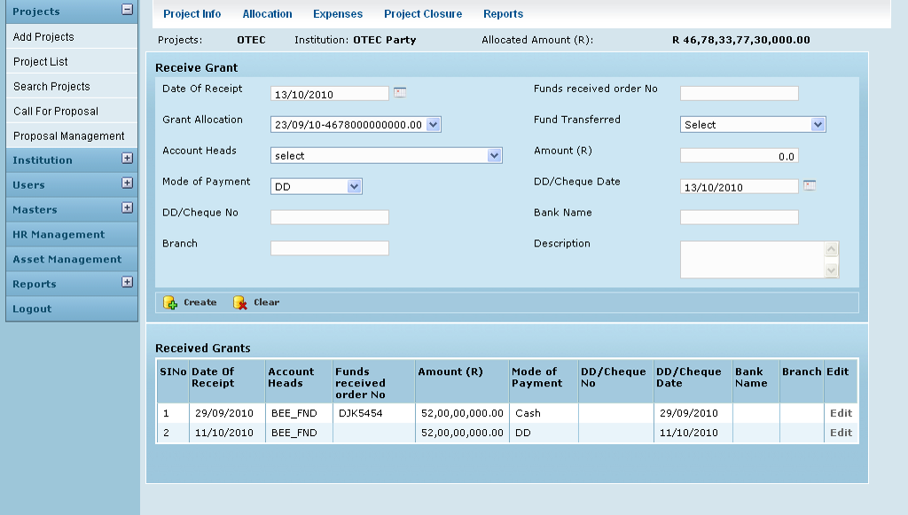

Field /Label | Input-Control | Data Type | Details
Projects: | Auto populated | String | Main Project - for the sub project of which, grant has been received
Institution: | Auto populated | String | Grantor institution which runs the main project.
Allocated Amount (R) | Auto populated | Number | The total allocation made by the grantor for entire project (inc this sub project)
Receive Grant
Date of Receipt | Calendar | Date | Required. Default selection: Current Date
Funds received order no: | Textbox | String | Required. Unique ID assigned manually by the subawardee – this may be a reference number sent by the grantor
Grant Allocation: | Listbox | String | Required
Fund Transferred | Listbox | String | Required. Options are the Fund transfers made by the grantor in the past towards this project, for which receipts have not been recorded.
Account Heads | Listbox | String
Amount (R) | Textbox autopopulated | Number | Required. The fund transferred amount value is captured here and is non editable
Mode of Payment | Textbox | String | Required
DD/Cheque No: | Textbox | String | Required
DD/Cheque Date | Calendar | Date | Required
Bank Name | Textbox | String | Required
Branch | Textbox | String | Required
Description | Textarea | String | Optional
Create |  |  | A grant receipt record is saved
Clear |  |  | Clears fields
Received Grants
Sl No
Date of Receipt | Auto populated | Date
Account Heads | Auto populated | String
Funds received order no: | Auto populated | String
Amount (R) | Auto populated | Number
Mode of Payment | Auto populated | String
DD/Cheque No: | Auto populated | String
DD/Cheque Date | Auto populated | Date
Bank Name | Auto populated | String
Branch | Auto populated | String
Edit | Button |  | Opens the Edit Grant Receipt page as shown in Figure 2

Edit Grant Receipt

Figure 2: Edit Grant Receipt
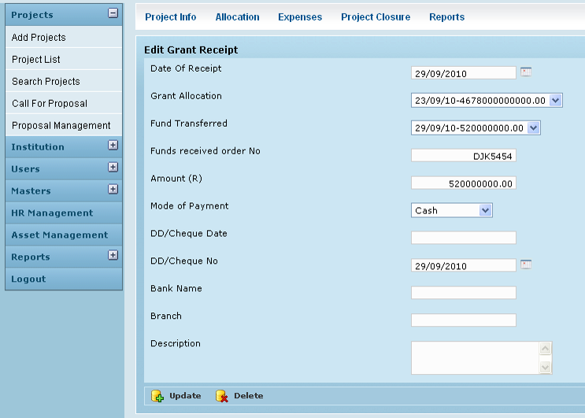

Field /Label | Input-Control | Data Type | Details
Edit Grant Receipt
Date of Receipt | Auto populated but editable Calendar | Date | Required
Funds received order no: | Auto populated but editable Textbox | String | Required
Grant Allocation: | Auto populated but editable Listbox | String | Required
Fund Transferred | Auto populated but editable Listbox | Number | Required
Amount (R) | Auto populated non editable Listbox | Number | Required
Mode of Payment | Auto populated but editable Textbox | String | Required
DD/Cheque No: | Auto populated but editable Textbox | String | Required
DD/Cheque Date | Auto populated but editable Textbox | Date | Required
Bank Name | Auto populated but editable Calendar | String | Required
Branch | Auto populated but editable Textbox | String | Required
Description | Auto populated but editable Text area | String | Optional
Create | Button |  | Grant receipt record changes saved
Delete | Button |  | Removes the entry

Business Rules
Grant Receipt can be recorded only if the corresponding fund transfer has been recorded by the grantor
Receipt can be recorded only against a specific fund transfer.
Receipt can be recorded only once for a specific fun transfer.
The received amount will be the same as fund transferred and is not editable

Status Messages

Sl No | Status Message
1 | Created Successfully
2 | Updated Successfully
3 | Deleted Successfully
4 | The Requested Record Not Found
5 | The Record can't be deleted, Already in use
6 | The Record Already Exists
7 | Please Enter a valid email address
8 | You can not delete yourself, please login as another admin and try again
9 | Amount already received against selected fund transfer
10 | Grant Receipt date should be greater than the date fund transferred by grantor
11 | Grant Received
12 | Please select Account Head
13 | Please select Mode Of Payment
14 | Please enter DD/Cheque No
15 | Please enter Bank Name
16 | Please enter Bank Branch
17 | Please enter Funds Received Order No.
18 | Please Enter Amount Less Than Or Equal To Balance Amount

